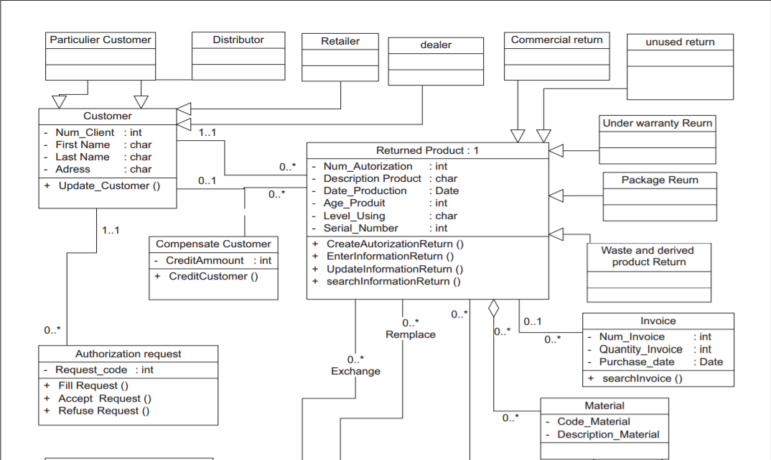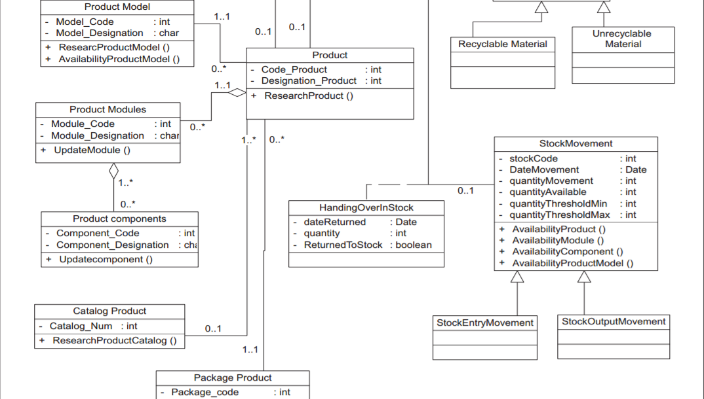

<http://ieeexplore.ieee.org/stamp/stamp.jsp?tp=&arnumber=7951381>

_______________

|ReturnedProduct|<>-->Material

|_______________|<>-->Customer

∆

|__________________________________________________________________________________

_________|_________ ______|______ ____|______ _______|________ _____|______

|UnderWarrantyReturn| |PackageReturn| |WasteReturn| |CommercialReturn| |UnusedReturn|

|___________________| |_____________| |___________| |________________| |____________|

________

|Customer|

|________|

∆

|____________________________________________________

__________|_______ _____|_____ ___|____ __|___

|ParticularCustomer| |Distributor| |Retailer| |Dealer|

|__________________| |___________| |________| |______|

________

|Material|

|________|

∆

|______________________________

_________|________ _________|__________

|RecyclableMaterial| |UnrecyclableMaterial|

|__________________| |____________________|

_____________

|StockMovement|<>-->ReturnedProduct

| | __________________

| |<>-->|HandingOverInStock|

|_____________| |__________________|

∆

|_____________________________

__________|_______ ________|__________

|StockEntryMovement| |StockOutputMovement|

|__________________| |___________________|

_______

|Invoice|<>-->ReturnedProduct

|_______|

__________________

|CompensateCustomer|<>-->Customer

|__________________|<>-->ReturnedProduct

____________________

|AuthorizationRequest|<>-->Customer

|____________________|

______________ _______ ______________

|PackageProduct|<>-->|Product|<>-->|ProductModules|<>-->ProductComponents

|______________| | | |______________|

| |

| | ____________

|_______|<>-->|ProductModel|

|____________|

______________

|CatalogProduct|<>-->Product

|______________|

____

|Card|

|____|

∆

|_____________________________________________________

__|__ ____|_____ ____|____ __|__

|Magic|<>-->Character |SearchCard| |Character| |Event|

|_____|<>-->CardHand |__________| |_________| |_____|

∆

_|__

|Ring|

|____|

________

|CardDeck|◄►-->Card

| | ________

|________|<>-->|CardHand|◄►-->Card

|________|<>-->Event